Name:_________________________________

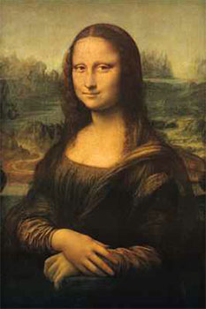
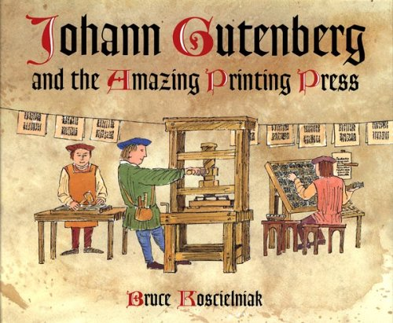
The Renaissance and Scientific Revolution

Aim: To what extent can the Renaissance and Scientific Revolution be considered Europe’s Golden Age?

Vocabulary
- Heliocentric Theory- The idea that the earth and the other planets revolve around the sun.
- Humanism- a Renaissance intellectual movement in which thinkers studied classical texts (Greco-Roman) and focused on human potential and achievements.
- Patron- A person who supports artists, especially financially.
- Perspective- An artistic technique that creates the appearance of three dimensions on a flat surface.
- Printing Press- Perfected by Johannes Gutenberg, a machine that presses images onto paper, making it possible to produced printed works quickly and cheaply.
- Renaissance- A period of European history, lasting from about 1300 to 1600, during which renewed interest in classical culture led to far-reaching changes in art, learning, and views of the world.
- Renaissance Man- A man who strove to master, and excelled in many fields of study.
- Scientific Method- A logical procedure for gathering information about the natural world, in which experimentation and observation are used to test hypotheses.
- Scientific Revolution- A major change in European thought, starting in the mid-1500s, in which the study of the natural world began to be characterized by careful observation and the questioning of accepted beliefs.
- Secular- Concerned with worldly rather than spiritual matters.
- Vernacular- The everyday language of people in a region or country.

People of the Renaissance and Scientific Revolution
Niccolo Machiavelli
Lorenzo de Medici
Michelangelo
Leonardo da Vinci
Desiderius Erasmus
Thomas Moore
William Shakespeare
Johannes Gutenberg
Copernicus
Galileo
Isaac Newton

